An explanation of

Q13 of SMAGS 2012 RR paper

Yes, I know that a) the exam is tomorrow so this isn’t going to be of much help and b) there’s an alternative solution provided courtesy of Conway Li in the “Compiled Specialist Questions” document, but I felt like adding my own explanation of the solutions provided.

Here’s the solution for the question- I’ve numbered the lines that I’m going to explain for easy reference. I’m not going to explain the top bit because I assume you already know more or less how an induction proof generally works.

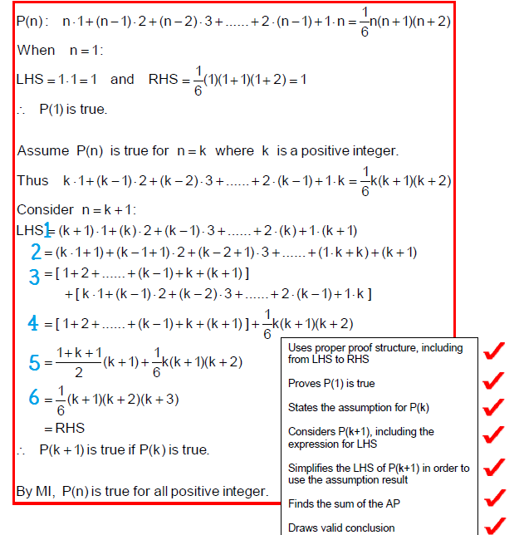

# Line 1

This line doesn’t really need that much explaining either… they’ve simply substituted k+1 into the equation.

# Line 2

Here they’ve expanded the integers to try and get them in line with the “assumed true” statement. (Sorry if that wasn’t a very technical/mathematically correct explanation.) You see, in the “assumed true” statement the first term has k, then the second term has k-1 etc. In Line 2 they’ve tried to match this by changing the second term to k – 1 + 1, and then k – 2 + 1 etc. Towards the end, they split 2k into k + k, which doesn’t make too much sense on its own (or at least it didn’t to me) so I’ll try and clarify over the next step or so. 3(k – 1) (the term before) was presumably split into 2k + k – 2 – 1 and then 2(k – 1) + (k – 1). I’ll tell you why I think this in the next step.

# Line 3

When you expand what you’ve got in Line 2, you end up with k + 1 + (k – 1)2 + 2 + (k – 2)3 + 3 etc. At the end, you’ve now got 2(k – 1) + (k – 1) + (1)k + k + (k + 1). You can now sort this out into two groups:

Group 1: the counting numbers. 1, 2, 3 all the way up to k and k+1.

Group 2: the terms in the original sequence. k + (k – 1)2 + (k – 2)3 up to 2(k – 1) and (1)k.

These two groups can be seen in Line 3 separated by square brackets.

# Line 4

The second group was factorised to (1/6)(k)(k + 1)(k + 2) in line with the assumption earlier. We still have our set of counting numbers to sort out.

# Line 5

Yup, the counting numbers can be factorised to that little equation there, but it’s better to try and understand why.

First of all, you can pair up the beginning and end numbers and add them together to get k + 2, and then the second from the beginning and second from the end to also get k + 2 etc. This gives you (k + 1)/2 lots of (k + 2). This leaves you with the equation that they’ve given, except they’ve arranged it differently.

# Line 6

The last line! Yay.

In this line, they’ve basically just factorised the whole thing:

$$\frac{\left(1+ k+1\right)}{2}\left(k+1\right)+ \frac{1}{6}k\left(k+1\right)\left(k+2\right)$$

$$=\left(k+1\right)\left(k+2\right)\left(\frac{1}{2}+\frac{1}{6}k\right)$$

$$=\frac{1}{6}\left(k+1\right)\left(k+2\right)\left(3+k\right)$$

$$=\frac{1}{6}\left(k+1\right)\left(k+2\right)\left(k+3\right)$$

Therefore statement is true for k+1.

And since a) I get a sense of satisfaction writing “QED,” especially with harder proofs (I’m lame like that) and b) the answers themselves don’t say QED, I’m going to add in a big fat QED right here.

QED!